Story of Positive Impact
Project : KfW Soil Project

- Project Village :- Maheshmara

- Farmer’s Name:- Lovely Singh Mob. No.- 81028448612
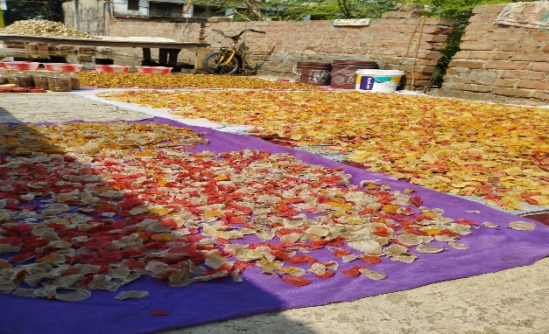
- Address :- At-Maheshmara, P.O-Baniyakura, PS-Katoria, Dist.- Banka, Pin-813106.
- Name of Activity:- Livelihood Support
- Month of Initiation:- March 2022
- Problem Statement :-
Women in rural areas are empty handed and they to support their families financially. Maheshmara is a prime village and house wives want to earn by doing some household activities.

- Initiation Taken :-
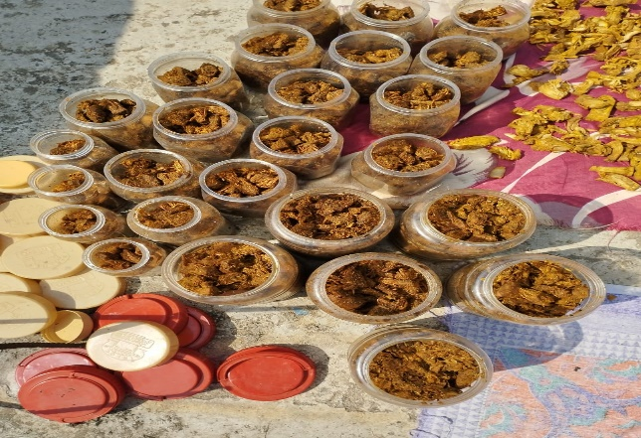
Lovely Singh formed a group of 4 other like-minded women and decided to make pickle, chips and badi(dry vegetable). They were provided support from the project. They were given training non-formally while doing the work. Kathal grows in abundance in the area. Potato is also grown and gram is all time available. They prepared Kathal Achar, Potato chips and Badi. The packed the products and started selling locally in the villages and in shops too. During the famous Saravani Mela this year they sold their products in almost all shops at kanwaria path, they are selling are selling now continuously and earning sufficiently.

- Progress And Result :-
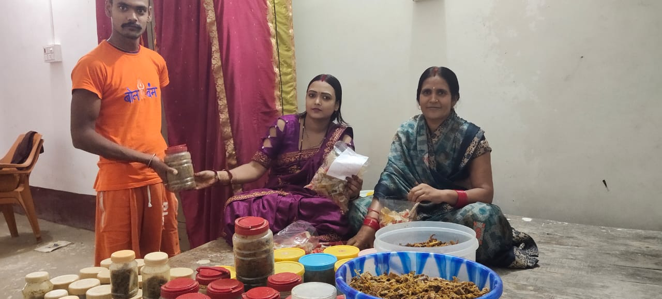
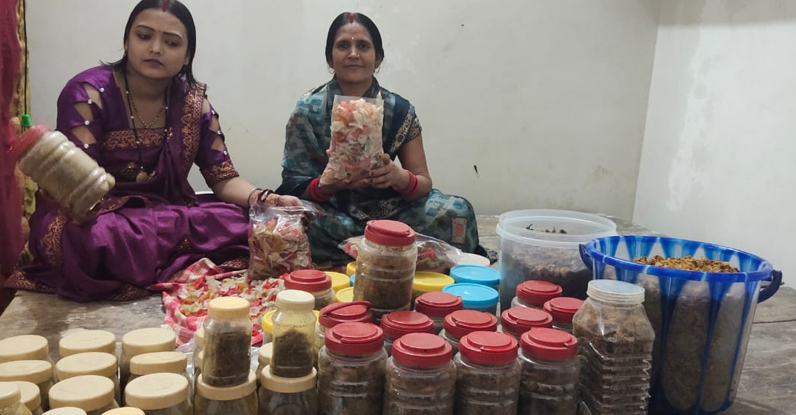
Now Achar, Chips and Badi re available in local market in packets and pots with printed price. It has been recognised in the community.

- Impact:-
The women-group is earning by side and their food habit and living style are improving slowly.

- Inspiration :-
An entrepreneur of Kutir Udyog attracts new groups rise.

